**STEP BY STEP INSTRUCTIONS TO COMPLETE THE FAFSA 2021-2022**

**1. Create an account (FSA ID)**

An [**FSA ID**](https://studentaid.ed.gov/sa/fafsa/filling-out/fsaid) is a username and password both parents and students will use on Federal Student Aid websites such as [fafsa.gov](http://www.fafsa.gov) and [StudentLoans.gov](http://www.StudentLoans.gov). If the child is considered a dependent student, two unique FSA IDs are needed to complete the FAFSA form online:

1. Parent’s FSA ID
2. Student’s FSA ID

Go to <https://fsaid.ed.gov> to create both a parent and a student FSA ID. Create FSA IDs before beginning the FAFSA, so there are no delays later in the process. FSA IDs serve as a way to submit a legal electronic signature throughout the federal student aid process. Do not share a FSA ID with anyone. Keep FSA ID information in a safe place. FSA IDs will also be used to renew a FAFSA form each year and to access federal student aid information online.

**2. Start the FAFSA® form at fafsa.gov**

* Go to [fafsa.gov](https://fafsa.gov/) and click “Start Here” under the “New to FAFSA.gov?” heading.
* Once on the log-in page, there will be two options. Pick which option is appropriate. Both ways will get the student the same results just will address the questions a little differently. [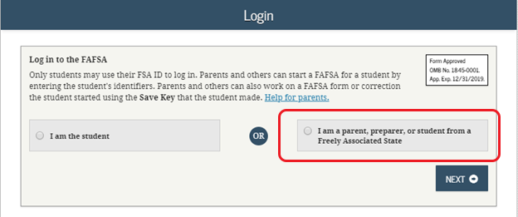](https://blog.ed.gov/files/2018/09/2019-20-Parent-Login.png)
* If the parent option is picked, the parent will be asked to enter their child’s name, Social Security number, and date of birth. Then, click next.
* Choose the 2021-2022 FAFSA form to complete.
* **IMPORTANT TIP— The FAFSA® form is the student’s application, not parents.**  
  When the FAFSA form says “you” or “your,” it is referring to the student (unless otherwise noted).  
  **If help is needed:** Click on the blue question mark symbol at the corner of each question.

**3. Fill out the Student Demographics section**

On the next page, student/parent will proceed to enter basic demographic information about the student, such as name, date of birth, etc. Make sure to enter the student’s personal information exactly as it appears on his or her Social Security card so no errors occur. (Do not use nicknames for the student.)

**4. List the schools that the student wants his or her FAFSA® information sent**

In the School Selection section, there is an option for colleges/universities to be added to receive the student’s information. It is important to add every school the student is considering, even if he or she has not applied or been accepted yet. It does not hurt to add more schools; colleges cannot see the other schools that have been added. Students or parents do not have to remove schools if the student later decides not to apply or attend. If the student does not end up applying or get accepted to a certain school, the school can just disregard his or her FAFSA form. Schools can be removed at any time to make room for new schools. Students can add up to 10 schools at a time.

**5. Answer the dependency status questions**

In this section, student or parent will be asked a series of specific questions to [determine whether or not the student is required to provide the parent information on the FAFSA form](https://studentaid.ed.gov/sa/fafsa/filling-out/dependency).

[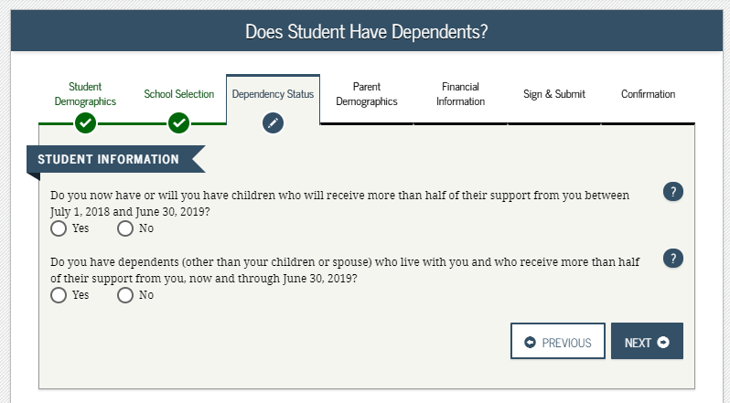](https://blog.ed.gov/files/2018/09/2019-20-Student-dependency-questions.png)

* These dependency guidelines are set by Congress and are different from those used by the Internal Revenue Service (IRS).
* Even if the student does not live with parents, supports him or herself, and files taxes separately from the parents, he or she may still be considered a dependent student for federal student aid purposes.
* If the student is determined to be a dependent student, he or she will be required to report information about his or her parents. If the student is determined to be an *independent* student, the student can skip the questions about providing parent information (unless otherwise noted by the school).

**6. Fill out the Parent(s) Demographics section**

This is where the parent(s) will provide demographic information. Are they divorced? Remarried? Below is a guide to determining which parents information needs to be included on the student’s FAFSA form. If you have a unique situation and are not sure how to fill it out, please email or call Mrs. McQueen.

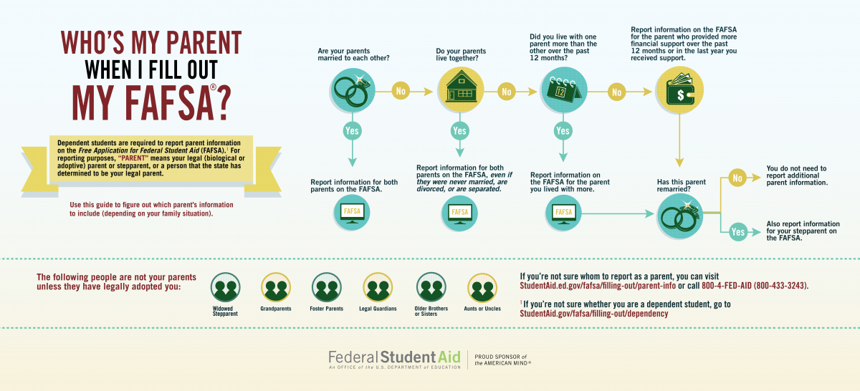

**7. Supply Student and Parent(s) financial information**

This step is incredibly simple if student and parent use the IRS Data Retrieval Tool (DRT). The IRS DRT allows student and parent to import IRS 2019 tax information into the FAFSA form with just a few clicks. Using this tool also may reduce the amount of paperwork needed to provide to the student’s school.

To access the tool, indicate that student or parent (whichever tax return information FAFSA is asking for first) “already completed” taxes on the finances page. If student or parent is eligible, an option to “Link to IRS” will appear. Parent tax information is usually first and then the student will need to submit his or her information if he or she filed taxes for 2019.

[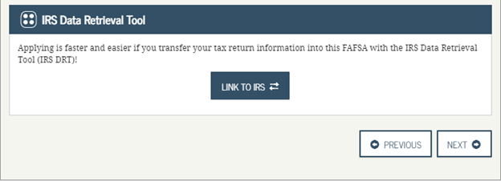](https://blog.ed.gov/files/2018/09/2019-20-IRS-DRT.png)

**8. Sign your child’s FAFSA® form**

Both parent and student need to sign the FAFSA form. The quickest and easiest way to sign the FAFSA form is online with both FSA IDs.

**Sign and Submit Tips:**

* Make sure parent and student do not mix up their FSA IDs. This is one of the most common errors seen, and why it is extremely important for each person to create his or her own FSA ID and not share it with anyone.
* Make sure the parent who is using his or her FSA ID to sign the FAFSA form chooses the right parent number. If they do not remember whether he or she was listed as Parent 1 or Parent 2, he or she can go back to the parent demographics section to check.

[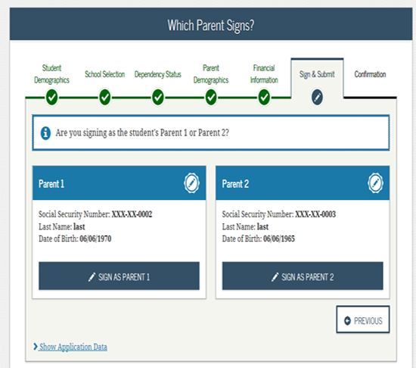](https://blog.ed.gov/files/2018/09/2019-20-Signatures-Which-Parent.png)

* If you get an error saying that your FSA ID information does not match the information provided on the FAFSA form, double check that parent is not signing with student’s FSA ID.
* By signing the student’s FAFSA form with the FSA ID, it allows the student’s information to be processed faster. However, if student and parent are unable to sign the FAFSA form electronically with an FSA ID, a signature page can be mailed.
* From the sign and submit page, select “Other options to sign and submit” and then choose “Print A Signature Page.” Just keep in mind that the student’s FAFSA form will take longer to process if student or parent go this route.
* If a parent has multiple children who need to complete the FAFSA form, that parent can use the same FSA ID to sign FAFSA forms for all of his or her children. The parent can also transfer his or her information into their other children’s applications by choosing the option provided on the FAFSA confirmation page.

[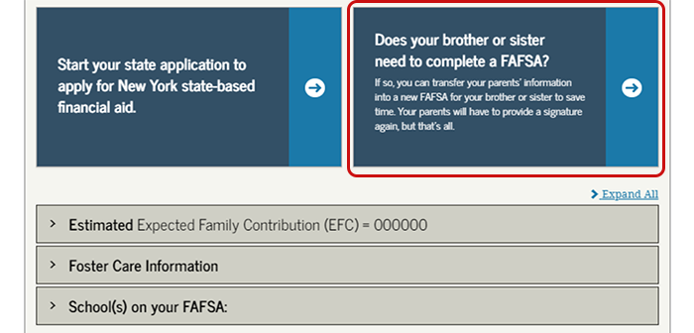](https://blog.ed.gov/files/2018/09/2019-20-Confirmation-Page-Transfer-Sibling.png)

**Congratulations!! All Finished!!! FAFSA will now send information on a report called the SAR on what the student is eligible to receive from the Federal Government for financial aid.**